arrownet-Global Service Guidelines

(JPX Co-Location Service)

Version 1.8
August 1, 2025
JPX Market Innovation & Research, Inc.

Table of Contents
- arrownet-Global Service Contents
  - arrownet-Global Service
  - Dedicated Line Service
  - JPX-Chicago Co-Location Direct Service
  - Extranet Service
  - Post-trade Direct
- arrownet-Global Fee Structure
  - Dedicated Line Service Fee Structure
  - Price List for Dedicated Line
  - Example of Dedicated Line Service Fees
  - JPX-Chicago Co-Location Direct Service Fee Structure
  - Price List for JPX-Chicago Co-Location Direct
  - Example of JPX-Chicago Co-Location Direct
Service Fees
  - Extranet Service Fee Structure
  - Price List for Extranet
  - Example of Extranet Service Fees
  - Post-trade Direct Fee Structure
  - Price List for Post-trade Direct
  - Example of Post-trade Direct Fees
- Application Process for arrownet-Global
  - Application Process to Becomearrownet-Global Carriers
  - Issuance of arrowface ID
  - Application Process for Dedicated Line and JPX-Chicago Co-Location Direct Service
  - Application Process for Extranet Service
  - Application Process for Post-trade Direct
- Required Items for arrownet-Global
  - Technical Restrictions
  - Confirmation Items for Operations
  - Demarcation Point and Responsibilities
- Contact List

About This Guide
- This document contains details of the arrownet-Global services provided by JPX Market Innovation & Research, Inc. (JPXI) for trading participants and CSPs including application processes, fee structure, and confirmation items for operations, etc.
- Customers are required to use arrownet-Global services appropriately by following the instructions in this document.
- Do not duplicate or disclose to third parties unless it is necessary for using the service.
- Revisions made to this document will be notified to customers 3 months in advance. However, minor amendments and other urgent amendments may be revised without any prior notice.
Document | Content | This doc
Terms and Conditions for Use of the arrownet Connection Service related to  provision of arrownet-Global Service | Terms and Conditions to be followed between the arrownet-Global Partner Carrier and JPXI for usage of arrownet Connectivity Service related to arrownet-Global Service Provision.
Terms and Conditions for Use of Co-  Location Service at the JPX Primary Site *Including additional terms | Terms and Conditions to be followed between a user and JPXI with respect to co-location service on the primary site.
Co-Location Service Guide (JPX Co-Location Service) | Instructions describing the procedures for using JPX Co-Location Service including installation, maintenance, operation, etc. of the equipment.
arrownet Guideline for Procedures/Operations (Common) | Instructions describing various procedures required for operation, maintenance, etc. in order to use arrownet.
arrownet Co-Location Connection Guidelines | This document describes the technical requirements, connection configuration, line items, etc. related to JPX Co-location and connection from Proximity to arrownet.
arrownet Guideline  for AP3 Co-Location External Exclusive Connection | This document describes the technical requirements, connection configuration, line items, etc. related to the service of AP3 Co-Location External Exclusive Connection
arrownet Guideline for Network Connection (Common) | This document describes the technical requirements, connection configuration, line items, etc. related to connection to arrownet.
arrownet-Global Service Guidelines | This document describes the various procedures for using arrownet-Global Services, the fee structure, and items to be confirmed related to operations. | ✓

Definition of Terms
Term | Definition
JPX | Abbreviation for Japan Exchange Group, Inc.
Customer(s) | Trading participant(s) or CSP(s) who have executed an arrownet Connection Service Provision Agreement with JPXI.
End User(s) | Investor(s) or vendor(s) who use arrownet-Global services through Customer(s).
CSP(s) | Co-Location Service Support Provider(s), who provides its clients with an order placement environment or other services by using a device(s) installed in the CoLocation Area.
Carrier | Communications service provider that lays External Connection Lines between arrownet Access Point(s) and User data centers.
JPX Co-Location Area | Refers to a room with racks provided to Customers at JPX Co-Location service.
AP | Abbreviation for Access Point. An entrance for accessing the JPX system. There are AP2, AP3 and AP4 Access Points.
SP (Service Provider) | Institutions (such as stock exchanges) where arrownet-Global service is connected to.
AP3 Co-Location External Exclusive Connection | Exclusive Network Services for JPX Co-Location External Connection at Access Point 3.

1. arrownet-Global Service Contents

1. arrownet-Global Service
◆ With the aim to enhance end user convenience for global access to the JPX market, JPXI is providing "arrownetGlobal" services for connectivity between end user’s global sites and JPX Co-Location Area via Network Carriers (arrownet-Global Carriers) who have partnerships with JPX.
- Three types of connections are expected to be provided to end users as arrownet-Global services shown below:*１
  - arrownet-Global (Dedicated Line) … Point to Point connection to JPX Co-Location
  - arrownet-Global (Extranet) … Point to Multi-Point connection to JPX Co-Location*2
  - Post-trade Direct … Point to Point connection to Clearing System
- End user’s sites in Japan cannot be connected via arrownet-Global services. (While it is not a problem that arrownet-Global Carrier network‘s PoP exists in Japan, communication via arrownet-Global by overseas sites and Japan’s sites should be separated. It is necessary that switches etc. for overseas sites and sites in Japan be physically separated or divide the VLAN settings.)
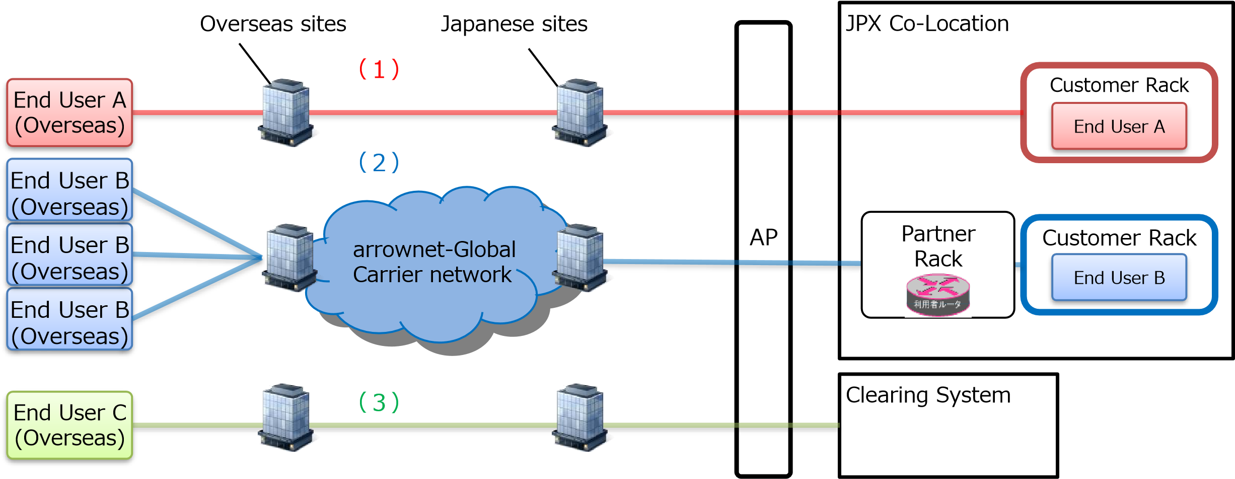
*1 It is prohibited to share a line connection between an AP and an arrownet-Global Carrier site in Japan.
*2 Point to Point communication can be provided by using the Extranet line.

2. Dedicated Line Service
Dedicated line service can be provided to End Users who place importance on reliability and stability with the connection between JPX Co-Location Area and an overseas site.
⚫ All lines from JPX Co-Location Area to overseas End Users are procured by arrownet-Global Carriers
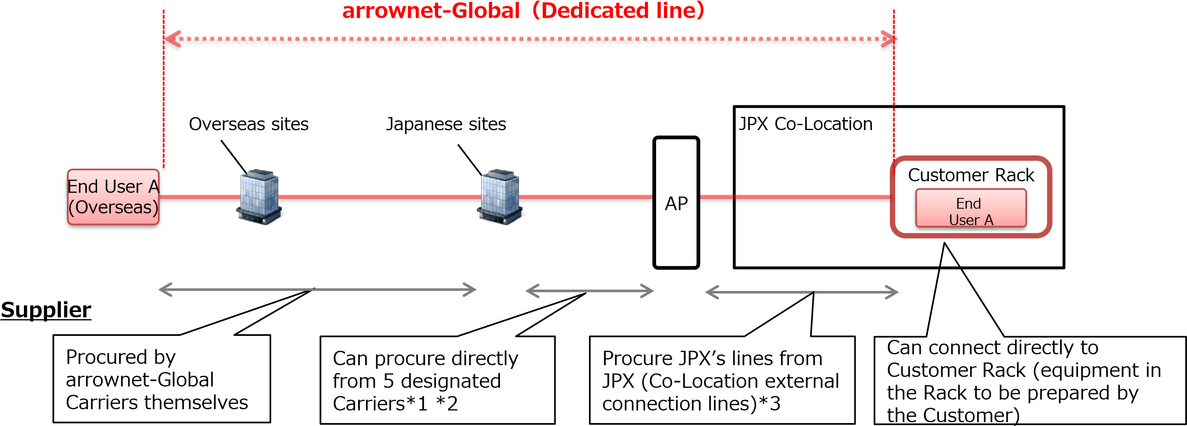
*1 NTT docomo Business, KDDI, Colt Technology, Softbank and @Tokyo (see Contact List toward end of document)
*2 If unable to procure a line from a site in Japan to an AP from the designated carriers, contact us for a separate consultation.
*3 Connect by arrownet line or AP3 Co-Location External Exclusive Connection.

3. JPX-Chicago Co-Location Direct Service
Dedicated line service can be provided to End Users who place importance on reliability and stability with the connection between the JPX Co-Location Area and the Chicago site (Aurora/Cermak).
⚫ End User can connect directly by applying to a Partner Carrier for a connection between the JPX CoLocation and a rack in the Chicago Data Center.
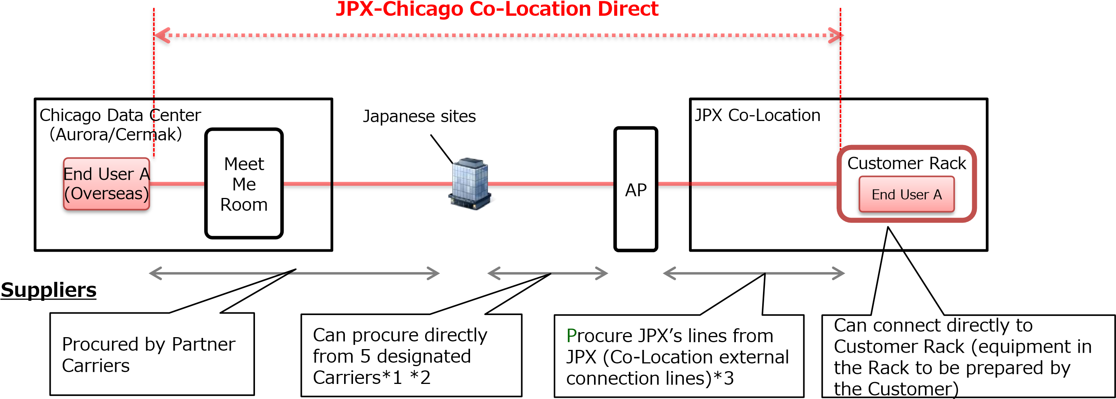
*1 NTT docomo Business, KDDI, Colt Technology, Softbank and @Tokyo (see Contact List toward end of document)
*2 If unable to procure a line from a site in Japan to an AP from the designated carriers, contact us for a separate consultation.
*3 Connect by arrownet line or AP3 Co-Location External Exclusive Connection.

4. Extranet Service
Extranet connection service can be provided to End Users who require connection to multiple overseas sites that are between JPX Co-Location and overseas sites.
⚫ All lines from the JPX Co-Location Area to overseas End Users will be procured by arrownet-Global Carriers.
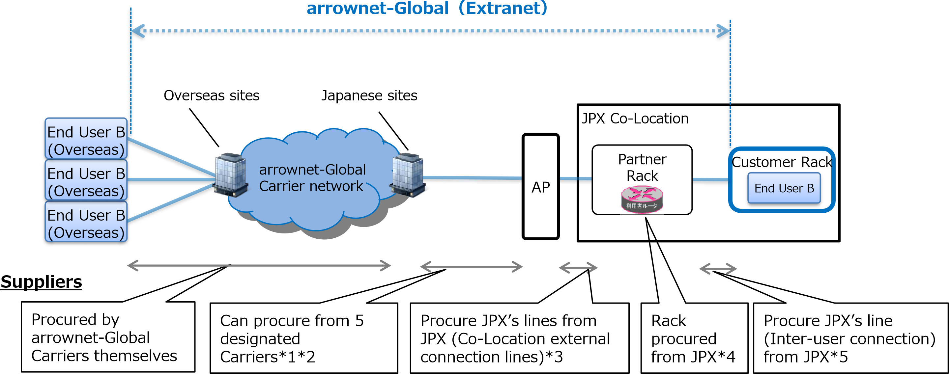
*1 NTT docomo Business, KDDI, Colt Technology, Softbank and @Tokyo (see Contact List toward end of document)
*2 If unable to procure a line from a site in Japan to an AP from the designated carriers, contact us for a separate consultation.
*3 Connect by arrownet line or AP3 Co-Location External Exclusive Connection.
*4 Only in the case where the End User is one company, connecting directly to a Customer Rack without using the Partner Rack is possible.
*5 The number of Inter-user connection could be set less than that of End User connection only if they are for the same End User.

5. Post-trade Direct
In order to strengthen the BCP function of users who also have back office functions overseas, a dedicated line connection service connecting to Clearing System* is provided. *Each clearing system for Listed products, OTC and JGB.
⚫ All lines between Clearing System and End Users site overseas are procured by arrownet-Global Carrier.
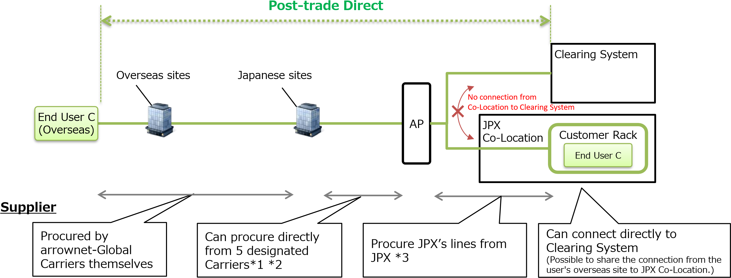
*1 NTT docomo Business, KDDI, Colt Technology, Softbank and @Tokyo (see Contact List toward end of document)
*2 If unable to procure a line from a site in Japan to an AP from the designated carriers, contact us for a separate consultation. *3 Connect by arrownet line

2. arrownet-Global Service Fee Structure

1. Dedicated Line Service Fee Structure
⚫ Every Dedicated line of End User is charged. It is necessary to divide the line for each End User.
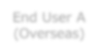
JPX Co
-
Location
End
User A
Customer Rack
Japanese Sites
Overseas sites
AP
End User A
(
Overseas
)
① arrownet Connection Service Fee
No. | Items | Details |  | Remarks
① | arrownet Connection Service Fee | - The lines from Customer Rack within JPX Co-Location to AP (Physical, Logical)  - Connection by arrownet or AP3 Co-Location External Exclusive Connection is possible. | ⚫  ⚫ | 1-year minimum period of use  Depending on bandwidth

2. Price List for Dedicated Line
arrownet Connection Service Fees

（1）For arrownet or AP3 Co-Location External Exclusive Connection^{*1}
No. | bps | Initial Fee (JPY) | Monthly Fee (JPY) | Standard delivery time | Remarks
① | 10G | 320,000 | 480,000 | 1.5 months | ⚫ Available AP: AP2, AP3, AP4
 | 1G | 120,000 | 202,800 | 1.5 months | ⚫ Available AP:AP2, AP3, AP4
 | 100M | 60,000 | 86,800 | 1.5 months
 | 50M | 60,000 | 63,400 | 1.5 months
 | 10M | 60,000 | 40,000 | 1.5 months
 | 2M | 60,000 | 27,600 | 1.5 months
- Regarding the payment period of a Dedicated line, the above usage fee for the current month, based on the invoice from JPXI, is paid by the end of two (2) months following the current month in a manner determined by JPXI. For example, a January usage fee invoice issued inearly February must be paid for by the end of March.
- If a contract is made in the middle of a month, that month’s usage fee will be prorated by the number of calendar days.
*1 AP3 Co-Location External Exclusive Connection is available with bandwidth 1G or 10G only at AP3.

3. Dedicated Line Service Fees (Examples)

Connection from 1 End User site (Overseas) to 1 Customer Rack
⚫ In this case, there is a connection from 1 End User site, therefore the charge will be for 1 line as the "arrownet Connection Service Fee“.
Example) In the case where the line from AP to Customer Rack has 1G, the billing is as follows:
⇒ arrownet Connection Fee [monthly fee (JPY 202,800)] *The initial fee (JPY 120,000) is charged at first billing
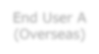
JPX Co
-
Location
Japanese sites
Overseas sites
End User A
(
Oversea
s
)
AP
End User A
Customer Rack

Connection from 2 End User sites (Overseas) to 1 Customer Rack
- In this case, there are 2 connections from 2 End User sites, therefore 2 lines will be charged as the "arrownet Connection Service Fee"
Example) In the case where the lines from AP to Customer Rack have 1G, the billing is as follows:
⇒ arrownet Connection Fee [monthly fee (JPY 202,800)] x 2= JPY 405,600 * The initial fee (JPY 120,000 x 2= 240,000) is charged at first billing
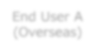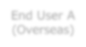
JPX Co
-
Location
Japanese sites
Overseas sites
End User A
(
Overseas
)
AP
End User A
Customer Rack
End User A
(
Overseas
)
4. JPX-Chicago Co-Location Direct Service Fee Structure
- End Users can connect to a rack at the Chicago Data Center from JPX Co-Location by submitting an application to a Partner Carrier for direct connection in between.
- Partner Carriers are able to procure and connect lines to JPX Access Point by themselves.
In this case, the fee will be lower than regular JPX arrownet.
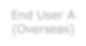
JPX Co
-
Location Area
End User

A
Customer Rack
AP
①

arrownet Connection Service Fee
Meet
Me
Room
Chicago Data

Center
（
Aurora/Cermak
）
Partner Carrier Connectivity
End User A
(
Overseas
)
No. | Items | Details |  | Remarks
① | arrownet Connection Service Fee | - The lines between Customer Rack within JPX Co-Location to AP (Physical, Logical)  - Can connect by arrownet or AP3 Co-Location External Exclusive Connection. | ⚫  ⚫ | 1-year minimum period of use  Depending on bandwidth

5. Price List for JPX-Chicago Co-Location Direct
arrownet Connection Service Fees

（1）arrownet or AP3 Co-Location External Exclusive Connection^{*1}
No. | bps | One-time Fee (JPY) | Monthly Fee (JPY) | Standard delivery time | Remarks
① | 10G | 300,000 | 450,000 | 1.5 months | ⚫ Available AP: AP2, AP3, AP4
 | 1G | 112,500 | 190,100 | 1.5 months | ⚫ Available AP: AP2, AP3, AP4
 | 100M | 56,300 | 81,400 | 1.5 months
 | 50M | 56,300 | 59,500 | 1.5 months
 | 10M | 56,300 | 37,500 | 1.5 months
- Regarding the payment period for JPX-Chicago Co-Location Direct, the fee for the current month, based on the invoice from JPXI, is paid by the end of two (2) months following the current month in a manner determined by JPXI.
- If a temporary charge arises at JPXI due to a change made in JPX arrownet for the convenience of the End User, the Partner Carrier shall pay the amount agreed to between both parties, based on the quotes from JPXI in the manner prescribed by JPXI by the due date designated by JPXI.
- If a contract is made in the middle of a month, that month’s usage fee will be prorated by the number of calendar days.
*1 AP3 Co-Location External Exclusive Connection is available with bandwidth 1G or 10G only at AP3.

6. JPX-Chicago Co-Location Direct Service Fee (Example)

Connection from 1 End User site (overseas) to 1 Customer Rack
⚫ In this case, there is a connection from 1 End User site, therefore 1 line will be charged as the "arrownet
Connection Service Fee"
Example) In the case where the line from AP to Customer Rack has 1G, the billing is as follows:
⇒ arrownet Connection Fee [monthly fee (JPY 190,100)] * The initial fee (JPY 112,500) is charged at first billing
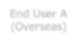
JPX

Co
-
Location Area
AP
Meet
Me
Room
Chicago Data

Center
（
Aurora/Cermak
）
End

User

A
Customer Rack
End User A
(
Overseas
)

Connection from 2 End User sites (overseas) to 2 Customer Racks
⚫ In the case, there are 2 connections from 2 End User sites, therefore 2 lines will be charged as the “arrrownet Connection Service Fee”
Example) In the case where the line for End User A has 1G and for End User B is 100M, the billing is as follows:
⇒ arrownet Connection Fee [monthly fee (End User A: JPY 190,100 + End User B: JPY 81,400) = JPY 271,500.
* The initial fee (End User A: JPY 112,500 + End User B: JPY 56,300 = JPY 168,800) is charged at first billing
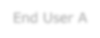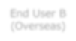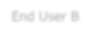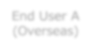
JPX Co
-
Location Area
AP
End User A
Customer Rack
Meet
Me
Room
Chicago Data

Center
（
Aurora/Cermak
）
End User B
(
Overseas
)
End User B
Customer Rack
End User A
(
)
Overseas

7. Extranet Service Fee Structure
⚫ Extranet service fees are charged based on the number of End Users and overseas sites, in addition to lines and Racks needed to connect to JPX.
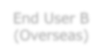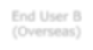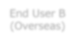
JPX Co
-
Location
End User B
Customer Rack
arrownet
-
Global
Carrier network
End User B
)
Overseas
(
End User B
(
)
Overseas
End User B
)
(
Overseas
AP
①

Partner Rack
Basic Fee
②
arrownet
-
Global (Extranet)
Connection Basic Fee*1
③

End User
Connection Fee*3
Partner
Rack
Japanese sites
Overseas sites
*1 arrownet line or AP3 Co-Location External Exclusive Connection to sites in Japan can be used instead of arrownet-Global (Extranet) basic Connection.
*2 It is also possible to connect directly to the user rack without using the partner rack only when there is only one user.
*3 Extranet’s End User Connection Fee is a charge based on the number of "End User overseas sites " communicating with JPX Co-Location, the number of "End Users", and the "bandwidth" used.
No. | Items | Details |  | Remarks
① | Partner Rack Basic Fee | ⚫ Usage fee of Partner Racks built in JPX Co-Location | ⚫ | 1-year minimum period of use
 |  |  | ⚫ | Building Racks are optional if the End User is only 1 company
② | arrownet-Global (Extranet) Connection Basic Fee | - Usage fee of physical line (arrownet) from Partner Racks or user racks(*2) in JPX Co-Location to AP  - Can connect via arrownet or AP3 Co-Location External Exclusive Connection | ⚫  ⚫ | Depending on bandwidth  1-year minimum period of use
③ | End User Connection Fee | ⚫ Usage fee of connections based on End User’s communication bandwidth and the number of overseas site connections(*3) | ⚫  ⚫ | Depending on bandwidth  No minimum usage period

8. Price List for Extranet（1/2）

（1）Partner Rack Basic Fee
No. | Air conditioning capacity | Initial Fee (JPY) | Monthly Fee (JPY) | Standard delivery time | Remarks
① | 8kVA | ― | 150,000 | 1 month | ⚫ It can not be used for purposes other than Extranet

（2） arrownet-Global (Extranet) Connection Basic Fee
➢ arrownet or AP3 Co-Location External Exclusive Connection ^{*1}
No. | bps | Initial Fee (JPY) | Monthly Fee (JPY) | Standard delivery time | Remarks
② | 10G | 400,000 | 250,000 | 1.5 months | ⚫ Available AP: AP2, AP3, AP4
 | 1G | 150,000 | 96,500 | 1.5 months | - Available AP: AP2, AP3, AP4  - If you want to install a line from a PoP in Japan to a Partner Rack using arrownet that JPXI provides separately, please contact us
 | 100M | 75,000 | 41,500 | 1.5 months
 | 10M | 75,000 | 19,000 | 1.5 months
 | Less than 5M | Quote Required | Quote Required | 1.5 months
*1 AP3 Co-Location External Exclusive Connection is available with bandwidth 1G or 10G only at AP3.

8. Price List for Extranet（2/2）

（3）End User Connection Fee
No. | bps | Initial Fee (JPY) | Monthly Fee (JPY) | Standard delivery time | Remarks
③ | 10G | ― | 350,000 | 1 week | ⚫ Each line must be applied for separately (End User x End User’s
 | 1G | ― | 157,000 | 1 week | overseas site)  - Each End User connection applied for will be charged for separately  - Can apply even if the End User connection’s total bandwidth usage exceeds the arrownet-Global (Extranet) Connection Basic line’s total bandwidth.  - If using a Partner Rack(s) to connect to a rack that is used by each End User, separate inter-user connection line(s) must be installed.  *Inter-user connection fee is included in the End User connection fee
 | 100M | ― | 67,000 | 1 week
 | 50M | ― | 49,000 | 1 week
 | 20M | ― | 40,000 | 1 week
 | 10M | ― | 31,000 | 1 week
 | 5M | ― | 27,000 | 1 week
 | 2M | ― | 25,000 | 1 week
 | 1M | ― | 18,000 | 1 week
 | 512K | ― | 10,000 | 1 week
 | 256K | ― | 7,000 | 1 week
- Regarding the payment period for Extranet, the above usage fee for the current month based on the invoice from JPXI is paid by the end of the current month in a manner determined by JPXI.
- If the usage fee happens to be from the middle of the month, it will be prorated daily by multiplying the number of days used by one thirtieth (1/30) of the monthly fee. If a fraction of JPY 1 results from such calculation it will be rounded down to the nearest whole number.

9. Extranet Service Fees (Examples) (1/2)

1 End User connecting from 3 End User sites (overseas) to 1 Customer Rack (with Partner Rack)
⚫ There are connections from 3 End User sites, therefore 3 lines of "End User Connection Fee" will be charged. Example: If the connection line (arrownet) bandwidth from AP to Customer Rack is 1G and End User connection line bandwidth is 50M, the billing will be as follows:
⇒ Partner Rack Basic Fee [monthly fee (JPY 150,000)] + arrownet-Global (Extranet) Connection Basic Fee [monthly fee
(JPY 96,500)] + End User Connection Fee [monthly fee (JPY 49,000)] × 3 lines = JPY 393,500







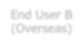





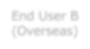


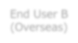



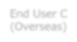






*The initial fee (JPY 150,000) is charged at the first billing
JPX Co
-
Location
End User B
Customer Rack
arrownet
-
Global
Carrier network
End User B
)
Overseas
(
End User B
)
Overseas
(
End User B
)
(
Overseas
End User C
)
Overseas
(
AP
Customer Rack
End User C
Partner
Rack
Japanese sites
Overseas sites
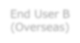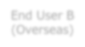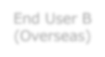
JPX Co
-
Location
End User B
Customer Rack
Partner
Rack
arrownet
-
Global
Carrier network
End User B
)
(
Overseas
End User B
(
Overseas
)
End User B
(
Overseas
)
AP
Japanese sites
Overseas sites
2 End Users connecting from 4 End User sites (overseas) to each Customer’s Rack (with Partner Rack)
⚫ There are connections from 4 End User sites, therefore 4 lines of "End User Connection Fee" will be charged.
Example: If the connection line (arrownet) bandwidth from AP to Customer Rack is 1G, End User connection line (User B) bandwidth is 50M and End User connection line (user C) bandwidth is 20M, the billing will be as follows:
⇒ Partner Rack Basic Fee [monthly fee (JPY 150,000)] + arrownet-Global (Extranet) Connection Basic Fee [monthly fee
(JPY 96,500)] + End User Connection Fee [monthly fee (JPY 49,000)] × 3 lines + (JPY 40,000) × 1 line] = JPY 433,500
* The initial fee (JPY 150,000) is charged at the first billing

9. Extranet Service Fees (Examples) (2/2)

1 End User connecting from 3 End User sites (overseas) to 1 Customer Rack (without Partner Rack)
⚫ There are connections from 3 End User sites, therefore 3 lines of "End User Connection Fee" will be charged. Example: If the connection line (arrownet) bandwidth from AP to Customer Rack is 1G and End User connection line bandwidth is 50M, the billing will be as follows:
⇒ arrownet-Global (Extranet) Connection Basic Fee [monthly fee (JPY 96,500)] + End User Connection Fee [monthly fee
(JPY 49,000)] × 3 lines = JPY 243,500 *The initial fee (JPY 150,000) is charged at the first billing
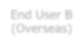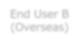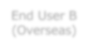
JPX Co
-
Location
End User B
Customer Rack
arrownet
-
Global
Carrier network
End User B
Overseas
(
)
End User B
)
Overseas
(
End User B
Overseas
)
(
AP
Japanese sites
Overseas sites

10. Post-trade Direct Fee Structure
⚫ Since Post-trade Direct can connect to multiple systems, a basic connection fee and a usage fee for a connected service will be charged for each line. It is necessary to have the line for each user/oversea site.
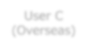
JPX

Co
-
Location
User Rack
Carrier POP
)
JPN
(
Carrier POP
)
(
Overseas
AP
①

Post
-
trade Direct

Basic Fee
Clearing System
②

Usage Fee of
Clearing System
③

Usage Fee of
JPX Co
-
Location
User C
(
Overseas
)
User C
No. | Item | Description |  | Remarks
① | Post-trade Direct Basic Fee | ⚫ Basic charge of Post-trade Direct | ⚫  ⚫ | Depending on bandwidth  1-year minimum usage period
② | Usage Fee of Clearing System | ⚫ Connection fee to clearing system | ⚫  ⚫ | Depending on bandwidth  Able to select the same or the  less bandwidth as of its Basic  Fee
③ | Usage Fee of  JPX Co-Location  (Optional) | - Usage fee for adding a connection to JPX Co-Location to PostTrade Direct  - Connection fee to JPX Co-Location rack | ⚫  ⚫ | Depending on bandwidth  Able to select the same or the  less bandwidth as of its Basic  Fee

11. Price List for Post-trade Direct（1/2）

Post-trade Direct Basic Fee
No. | bps | Initial Fee (JPY) | Monthly Fee (JPY) | Standard delivery time | Remarks
① | 10G | 400,000 | 250,000 | 1.5 months | ⚫ Available AP：AP2,AP3,AP4
 | 1G | 150,000 | 96,500 | 1.5 months
 | 100M | 75,000 | 41,500 | 1.5 months
 | 50M | 75,000 | 30,300 | 1.5 months
 | 10M | 75,000 | 19,000 | 1.5 months
 | 2M | 75,000 | 7,500 | 1.5 months
Usage Fee of Clearing System

（1）Connecting Production Environment or Test Environment
No. | bps | Initial Fee (JPY) | Monthly Fee (JPY) | Standard delivery time | Remarks
②-1 | 1G | - | 157,000 | 1.5 months | ⚫ Select the environment  (production / test) to connect in advance and apply
 | 100M | - | 67,000 | 1.5 months
 | 50M | - | 49,000 | 1.5 months
 | 20M | - | 40,000 | 1.5 months
 | 10M | - | 31,000 | 1.5 months
 | 5M | - | 27,000 | 1.5 months
 | 2M | - | 25,000 | 1.5 months
 | 1M | - | 18,000 | 1.5 months
 | 512k | - | 5,000 | 1.5 months
- Both basic and usage fees above for the current month, based on the invoice from JPXI, is paid by the end of two (2) months following the current month in a manner determined by JPXI. For example, a January usage fee invoice issued in early February must be paid by the end of March.
- If a contract is made in the middle of a month, that month’s usage fee will be prorated by the number of calendar days.

11. Price List for Post-trade Direct（2/2）

Usage Fee of Clearing System （２） Connecting both Production Environment and Test Environment
No. | bps | Initial Fee (JPY) | Monthly Fee (JPY) | Standard delivery time | Remarks
②-2 | 1G | - | 236,000 | 1.5 months
 | 100M | - | 101,000 | 1.5 months
 | 50M | - | 74,000 | 1.5 months
 | 20M | - | 60,000 | 1.5 months
 | 10M | - | 47,000 | 1.5 months
 | 5M | - | 41,000 | 1.5 months
 | 2M | - | 38,000 | 1.5 months
 | 1M | - | 27,000 | 1.5 months
 | 512k | - | 8,000 | 1.5 months

Usage Fee of JPX Co-Location
No. | bps | Initial Fee (JPY) | Monthly Fee (JPY) | Standard delivery time | Remarks
③ | 10G | - | 350,000 | 1.5 months
 | 1G | - | 157,000 | 1.5 months
 | 100M | - | 67,000 | 1.5 months
 | 50M | - | 49,000 | 1.5 months
 | 20M | - | 40,000 | 1.5 months
 | 10M | - | 31,000 | 1.5 months
 | 5M | - | 27,000 | 1.5 months
 | 2M | - | 25,000 | 1.5 months
 | 1M | - | 18,000 | 1.5 months

12. Post-trade Direct Fee (Example)

Connection from End User site (Overseas) to Clearing System
⚫ In this case, there is a connection to Clearing System (Production Environment), therefore the charge will be “Post-trade Direct Basic Fee” and “Usage Fee of Clearing System.”
Example) Bandwidth is 10M
⇒ Post-trade Direct Basic Fee [19,000 JPY/month]+ Usage Fee of Clearing System [31,000 JPY/month] ＝ 50,000 JPY/month In addition, 75,000 JPY as initial fee is charged.
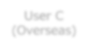
Carrier POP
(
JPN
)
Carrier POP
(
Overseas
)
User

C
(
Overs
eas
)
AP
Clearing System
10
M

Connection from End User site (Overseas) to Clearing System and JPX Co-Location
⚫ Since a connection is to Clearing System (Production Environment) and JPX Co-Location, “Post-trade Direct Basic Fee,” “Usage Fee of Clearing System” and “Usage Fee of JPX Co-Location” are charged.
Example) 10M of Clearing System connection and 1G of JPX Co-Location connection (Basic Connection is 1G) ⇒ Post-trade Direct Basic Fee [96,500JPY/month]+ Usage Fee of Clearing System [31,000JPY/month] + Usage Fee of JPX Co-Location [157,000 JPY/month]
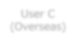
＝

JPY/month
284,500
In addition, 150,000 JPY as initial fee is charged.
JPX Co
-
Location
User C
User Rack
Carrier POP
)
(
JPN
Carrier POP
Overseas
)
(
AP
User

C
(
Overseas
)
Clearing System
M
10
G
1

3. Application Process for arrownet-Global

3-1. Application Process to Become arrownet-Global Carrier
⚫ Application process for Network Carriers to become an arrownet-Global Carrier is as follows:
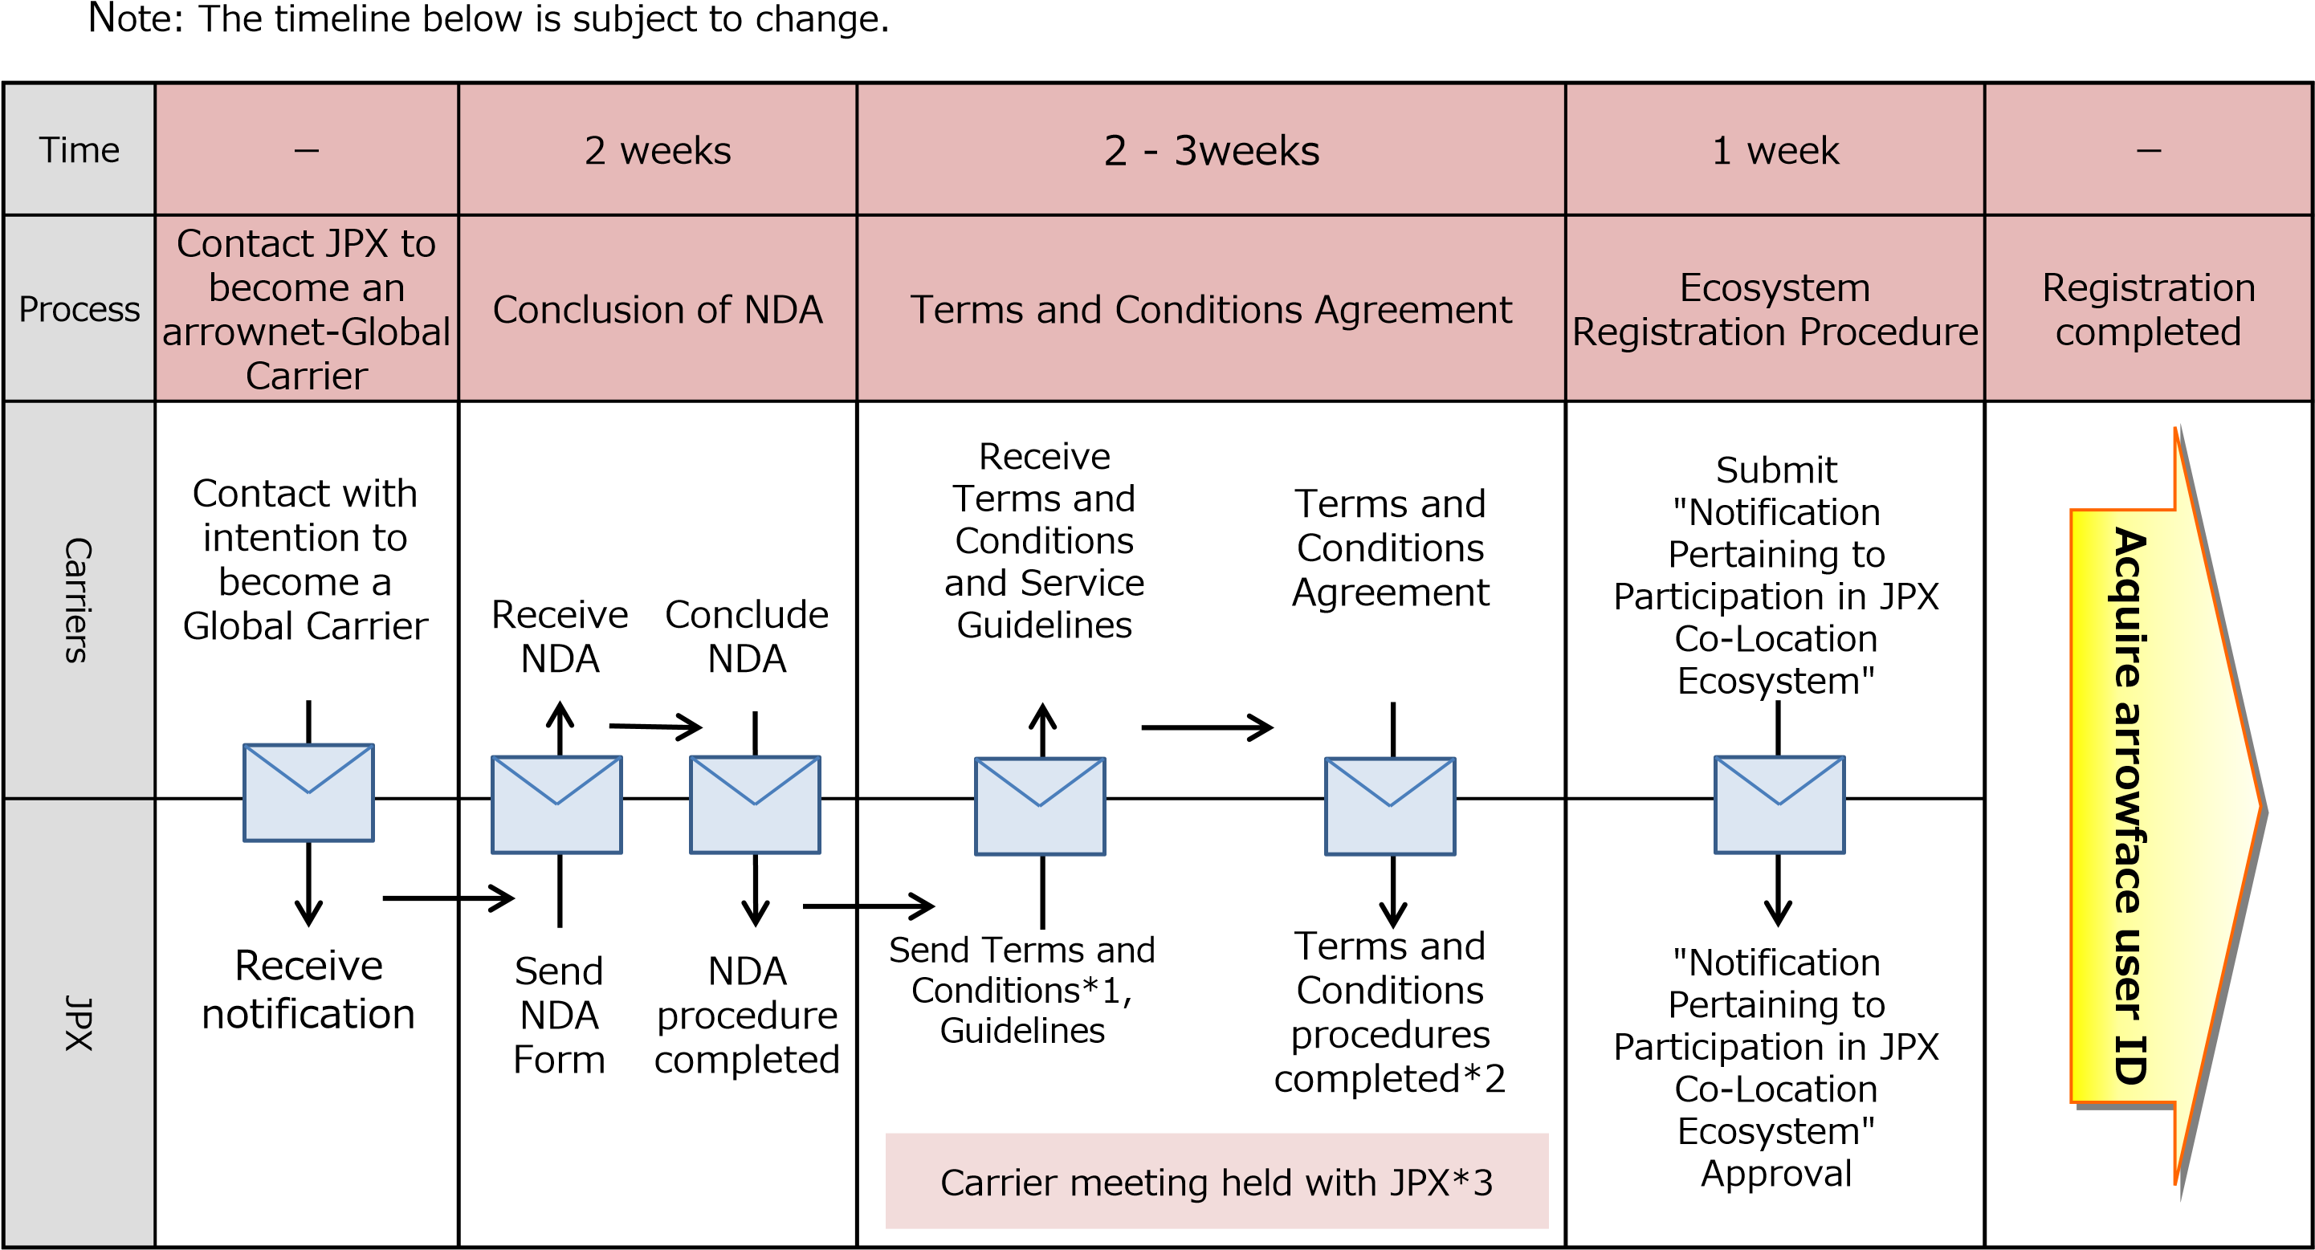
*1 A Terms and Conditions Agreement is required to provide dedicated line service, JPX-Chicago Co-Location Direct, extranet service and Post-trade Direct.
*2 After completing procedures for Terms and Conditions, JPXI will send documents for "arrowface ID application" and "Notification Pertaining to Participation in JPX CoLocation Ecosystem."
*3 This is held to make sure everyone is on the same page regarding provision conditions, a system of contacts flow in case of line failure, etc. （If the usage start date is close, the meeting will be held as soon as possible.）

2. Issuance of arrowface ID
⚫ Application flow for arrownet-Global Carrier to obtain arrowface ID is as follows:
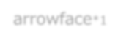
Time
weeks
2
week
1
ー
Process
Submitting application for
arrowface user ID
Registration of
Master billing information and various
contact details
Application
Preparations
Complete
Carriers
JPX
Note: The timeline below is subject to change.
Can apply for lines*
2
arrowface
*1
Sends the
application form
Receive the
application form
Fill out necessary
information and
send
Confirms the
information and
issues arrowface
ID
Registration of
Master billing
information and various
contact details
Approve Master
billing information
and various
contact details
*1 Please contact the JPX service desk regarding the usage of arrowface (see JPX Contact in a following slide).
*2 After obtaining arrowface ID, Carriers can submit application for lines at the same time as registration of Master billing information and various contact details

3-3. Application Process for Dedicated Line and JPX-Chicago Co-Location Direct
- Application flow for arrownet-Global Carrier to connect dedicated line/JPX-Chicago Co-Location Direct is as follows:
Note: The timeline below is subject to change.
- arrownet-Global Carriers are to submit applications to JPXI.
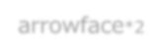
Time
ー
week
1
weeks
2

1
-
months
1.5
ー
Process
Coordinate with End
Users
Quotation for line fees
Line usage Application
Preparation for start of usage
Usage
preparation
Complete
Carriers
JPX
arrowface
*2
Coordinate with
End Users
Submit
application for
quotation of new
arrownet line fees
(
physical line and
logical line)*1
Submit
application for new
arrownet line
physical line
(

and
logical line)*1
Receive the quotation
application and reply
with a price quote
Receive and approve
application
Install new lines
Link new line with
billing and contact
information
Start of use
*1 When submitting a "new arrownet line quote request" and/or "application for new arrownet line", the following information must be included: Contractor name of rack, Port No. of rack, carrier line ID, End User name and termination address, etc.
*2 Please contact the JPX service desk regarding the usage of arrowface (see JPX Contact in a following slide).

4. Application Process for Extranet (1/2)
⚫ Application process (Partner Rack Cabinets and arrownet line) for connecting Extranet is as follows:

Time
*1
1
week
2
weeks
*1
1

-
months
1.5
ー
Process
Application for
Rack Cabinet
Quotation for line
fees
Application for
using lines
Usage of Rack
Cabinet
Preparation for usage start
Usage
preparation
complete
Carriers
JPX
Note: The timeline below is subject to change.
arrowface
*4
Start of use
Submit Application
for new arrownet
line quotation*3
(
physical line and
logical line)
Submit new
usage
application for
Partner Rack
Cabinet*2
Receive and
approve the
application
Submit
Application for
new arrownet
line*3
physical line and
(
logical line)
Receive the
application and
reply with price
quote
Receive and
approve the
application
Provide Rack
Cabinets
Start using
Rack Cabinet
Install new
lines
Link new line
with billing
and contact
information
*1 If rack usage is desired, a "Terms and Conditions for Use of Co-Location Service at the JPX Primary Site (Partnership scheme)" must be agreed to. arrownet line application can be done at the same time although the standard delivery date from approval of Rack cabinet application to the start of use is 1 month.
*2 Only for an End User that is just one company, rack usage is optional, and it is not mandatory to submit an "Application for New Partner Rack Usage". However, if you wish to use a Rack Cabinet, please observe the specified Terms and Conditions.
*3 When submitting a "new arrownet line quote request" and/or "new application for arrownet line", the following information must be included: Contractor name of rack, Port No. of rack, carrier line ID, End User name and termination address information, etc. .
*4 Please contact the JPX service desk regarding the usage of arrowface (see JPX Contact in a following slide).

4. Application Process for Extranet (2/2)
⚫ Application process (End-User connection and Inter-User connection) for connecting Extranet is as follows:
Note: The timeline below is subject to change.
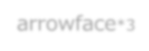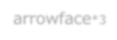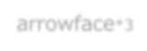
Time
ー
week
1
week
1
ー
Process
Coordination
with End Users
Application for End
-
User
Connection
Application for Inter
-
User
Connection Usage
Preparation for usage
start
Usage
preparation
complete
Carriers
JPX
Rack user
)
(
End User
Start of use
from the effective date
arrowface
*3
Coordinate with
End Users
Submit
application for
End
-
User Connection*1
Receive and approve
the End
-
User
Connection application
arrowface
*3
Receive and approve
the Inter
-
User
Connection application
Install Inter
-
User
Connection lines
New application for
Inter
-
User
Connection*2
New application for
Inter
-
User
Connection*2
arrowface
*3
*1 Clearly indicate End User name, contracted bandwidth, End User site, etc. in “application for End-User Connection”.
Also, carriers can submit Applications respectively for the End-User Connection and New Application for Inter-User Connection at the same time.
*2 Please also fill out the End User name on the Application for Inter-User Connection. The order for applying is (1) from arrownet-Global Carrier -> (2) from Rack User to ->
(3) JPXI approval. Also, if an arrownet-Global Carrier connects without a partner rack, please contact us for a separate consultation.
*3 Please contact the JPX service desk regarding the usage of arrowface (see JPX Contact in a following slide).

4. Application Process for Post-trade Direct
- Standard application flow for arrownet Global Carrier to order Post-trade Direct is as follows:
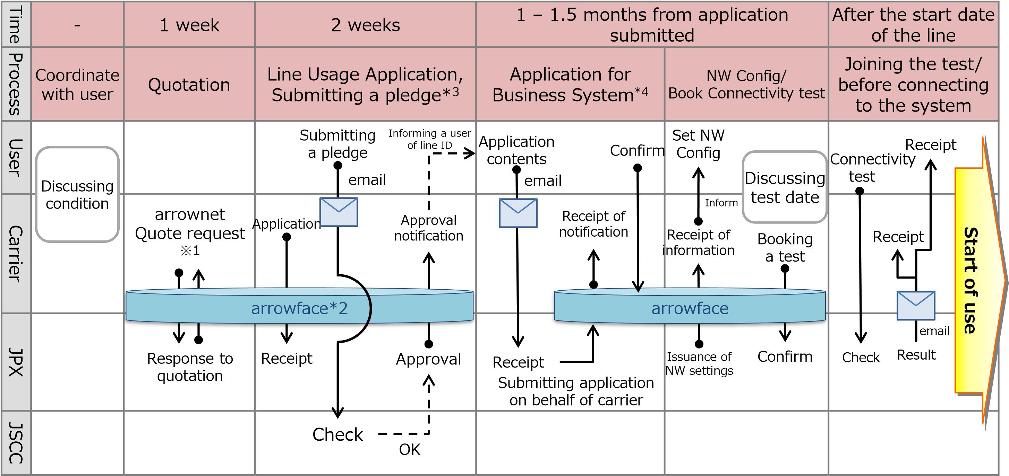
- The arrownet-Global Carrier applies for the line, and JPX ServiceDesk on behalf of the user applies for the usage of business system based on the information provided from the user.
*1 When submitting a quote request or line usage application, Carrier Line ID, User Name and Termination Point have to be stated.
*2 To get an arrowface ID, please contact JPX ServiceDesk.
*3 A pledge is submitted from user to JSCC.
*4 If the user is not a clearing participant but a system vendor, the flow of business system application will be different. Please contact JPX Service Desk for details.

4. Required Items for arrownet-Global

1. Technical Restrictions (1/6)

AP Interface
- Handoff at AP2 for over 1G are provided with optical fiber and for other bandwidths with metal lines.
- Basically, the handoff at AP3 and AP4 is the same as AP2, besides, the optical fiber is also available for bandwidth equal or less than 100M if using @Tokyo intra-building cross connection service.
(In the case of AP3 in CC1, optical fiber is available only with Intra-building-Cross Connection Service provided by @Tokyo.)
Physical Interfaces provided (AP side)*1
Bandwidth | Media Type | Connector  Type | Cable Specifications | User Device Interface Configuration  （speed/duplex）
10Gbps | 10GBASE-LR | LC | single mode | auto/auto
1Gbps | 1000BASE-LX | LC | single mode | auto/auto
≤100Mbps | 1000BASE-LX | LC | single mode | auto/auto
*1 When selecting @Tokyo, the interface settings is in the above table. but the procurement is possible from 5
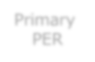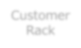
designated Carriers also.
PP
Primary

PER
AP
PER
AP room
JPX Co
-
Location room
PP
PP
Customer
Rack
arrownet
-
Global
Carrier’s site
in Japan
PP
*
１

1. Technical Restrictions (2/6)

Co-Location external connection interface
⚫ Handoff in the JPX Co-location Area will be provided with optical fiber for all the bandwidths when a user newly order arrownet-Global.

Physical Interfaces (External Connection Lines (PtoP))*1
Bandwidth | Media Type | Connector Type | Cable Specifications | User Device Interface Configuration  (speed/duplex)
10Gbps | 10GBASE-LR | LC | Optical Fiber Cable (single mode) | auto/auto
1Gbps | 1000BASE-LX
≤100Mbps*2
 | 100BASE-TX | RJ-45 | Cat5e and above UTP | 100/full
*1 For details, please refer to “arrownet_Guideline_for_NW_Connection (JPX).“
Please note that the bandwidth for AP3 Co-Location External Exclusive Connection is provided at 1Gbps or 10Gbps. For more details, please refer to "arrownet [AP3 Co-Location External Exclusive Connection]".
*2 From August 2025, we will stop accepting new orders with 100BASE-TX and will start to provide with 1000BASE-LX.
*3 Please select and connect the cables considered for the port types of the arrownet device and End User devices port type.
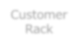
PP
Primary

PER
AP
PER
AP room
JPX Co
-
Location room
PP
PP
Customer
Rack
a
rrownet
-
Global
Carrier’s site
in Japan
PP
*3

1. Technical Restrictions (3/6)

Usage of Jumbo Frame
⚫ In the arrownet network, a maximum frame length of 1522 bytes* can be transmitted. As a special case, where the bandwidth of the physical line is over 1Gbps and the physical line is exclusively used for L2VPN only,
a maximum frame length may be expanded to 1596 bytes subject to the prior application.^{*1} ⚫ For details, please refer to "arrownet Guidelines for NW Connections (Common)“.
*The maximum frame length for AP3 Co-Location External Exclusive Connection is 1600 bytes (default value). For details, please refer to arrownet Guideline [AP3 Co-Location External Exclusive Connection].

JPX Co
-
Location
End
User A
Customer Rack
End
User B
Customer Rack
AP
Partner
Rack
Subject Lines
Extranet
Dedicated line
*1: Where the maximum frame length of a carrier line is below bytes mentioned above, the limit will be that of the lower frame length. For details, please refer to the Appendix to the Terms of Use for arrownet Connection Service, “arrownet Price List”.

About the VLAN setting
⚫ User must attach a VLAN tag which is assigned by JPX when connecting to arrownet. For details, please refer to "arrownet Guidelines for NW Connections (Common)".
VLAN tagging is not required for the connections using AP3 Co-Location External Exclusive Connection.
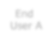
User sites

in Japan
JPX Co
-
Location
End
User A
Customer Rack
End
User B
Customer Rack
AP
Partner
Rack
Extranet
Dedicated line

1. Technical Restrictions (4/6)

Connection setting restrictions
- arrownet-Global Carrier needs to prevent unnecessary communications from flowing to the arrownet network by separating the network from external sites and Co-Location areas by installing L3 equipment and firewall etc. Communications with a different Customer cannot be transmitted.
- If the contract bandwidth is smaller than the physical line bandwidth, JPX will control the bandwidth of lines from AP to the JPX Co-Location Area ー ①
- Procure lines matching the bandwidth of the line from AP to JPX Co-Location Area for the lines (procured by arrownet-Global Carriers or designated Carriers) from overseas End User sites to AP. ー ②
JPX controls the bandwidth at AP. Therefore, regardless of the bandwidth from the AP to overseas user sites, users can only use the contract bandwidth*1
*1 It is possible to use physical lines that are different from the contract bandwidth, but in that case the carrier must obtain agreement from the End User beforehand. JPX controls the bandwidth at AP, therefore arrownet-Global Carriers are responsible for any failure caused by the difference in bandwidth. For details about bandwidth control, refer to "arrownet Guidelines for NW connections (Common)".

② ①
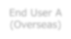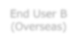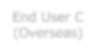
JPX Co
-
Location
End User A
Customer Rack
End User B
Customer Rack
Extranet
Dedicated line
Overseas sites
Japanese sites
End User A
Overseas
(
)
End User B
(
Overseas
)
Partner
Rack
arrownet
-
Global
Carrier network
Clearing System
End User C
(
Overseas
)
AP
Post
-
trade Direct

1. Technical Restrictions (5/6)
Post-trade Direct

[Matters to be noted by users of Post-trade Direct] Configuration
- To connect to the business system, it is necessary for a user to set a specific VLAN.
  - When sharing a connection of Post-trade Direct with connection to Co-Location, a user sets two VLANs.
  - For details, please refer to 9.3 L3VPN in "arrownet Guidelines for NW Connections (Common).“
- When configuring user LAN IP addresses on user routers, please configure user routers with router configuration information assigned. Please do not connect from other lines except for arrownet connection lines within the range of user LAN IP address assigned.
  - The assigned information can be confirmed by the carrier on arrowface, and it is carrier’s responsibility to inform configuration information to user.
- When a bandwidth of the line is different from the interface link speed*, the user controls traffic volume to stay below the bandwidth. JPX implements bandwidth control at its access point.
*When using 100M of physical line and sharing 100M of JPX Co-Location connection and 20M of Clearing System connection.
The user sets the specified VLAN and assigned setting information (user LAN, etc.)
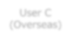
Carrier Site (JPN)
Carrier Site (Overseas)
User C
(
Overseas
)
AP
Clearing System

Network Configuration
- Please install the router or L3SW on the demarcation point between user network and arrownet in order to separate the network.
- In the case of connecting to networks other than arrownet, please avoid communicating with hosts other than those specified by JPX by setting up firewalls or using multiple NATs or NICs to segregate the network.

1. Technical Restrictions (6/6)
Post-trade Direct
[Matters to be noted by users]

Prohibited matter
⚫ Please make appropriate arrangements so that user routers do not transmit unnecessary data for arrownet (including connection from any IP address not issued by JPX), utilizing routing rules or packet-filtering functions.

Security
- In order to prevent unauthorized access to JPX network, please take security measures with high robustness in the user network environment.
- When detecting illegal transmission(including contact from JPX), take measures such as shutting off the connection promptly.

Others
⚫ If user changes network configuration without satisfactory connection results, make sure that user perform production transmission after checking the normality by holiday test.

2. Confirmation Items for Operations (1/3)
Failure monitoring
- Port monitoring (Link-Down) will be conducted only for the arrownet equipment (PE router), and polling will not be performed for user equipment installed in Co-Location area and user sites.
- On weekdays and holidays, there is a time slot for maintenance work, so there is a possibility of line disconnection. If a line disconnection occurs for 1 second or more, JPX will make a notification beforehand by e-mail. For details, please refer to "arrownet Guideline for Procedures and Operations (Common)". Troubleshooting
- When a network failure occurs, JPX is in communication with arrownet-Global Carriers.
- arrownet-Global Carriers are responsible for contacting their End Users (Overseas users).
- When an alert is detected on the above monitoring system and it is determined that an emergency report is necessary, it will be notified by e-mail and telephone. The e-mail will be sent to three contact addresses registered for emergencies. The phone call will be made to the main person in charge first, then sub-contact 1 followed by sub-contact 2 in case the main person is not available. If the causes are not on the End User side, JPX will report on the estimated time for recovery and make continual updates to the recovery details. Also, after recovery JPX will report on the cause and the impact on service, and measures to prevent a recurrence.
- Fault report service desk is only available in Japanese. *In principle, the service desk is not available in English. Please establish a team include a Japanese speaker(s).
- Also, note that during holidays (normally from 7:15 a.m. Saturdays to 5:00 a.m. Mondays) contact will only be made if a disconnection is detected on the line for more than 10 minutes.
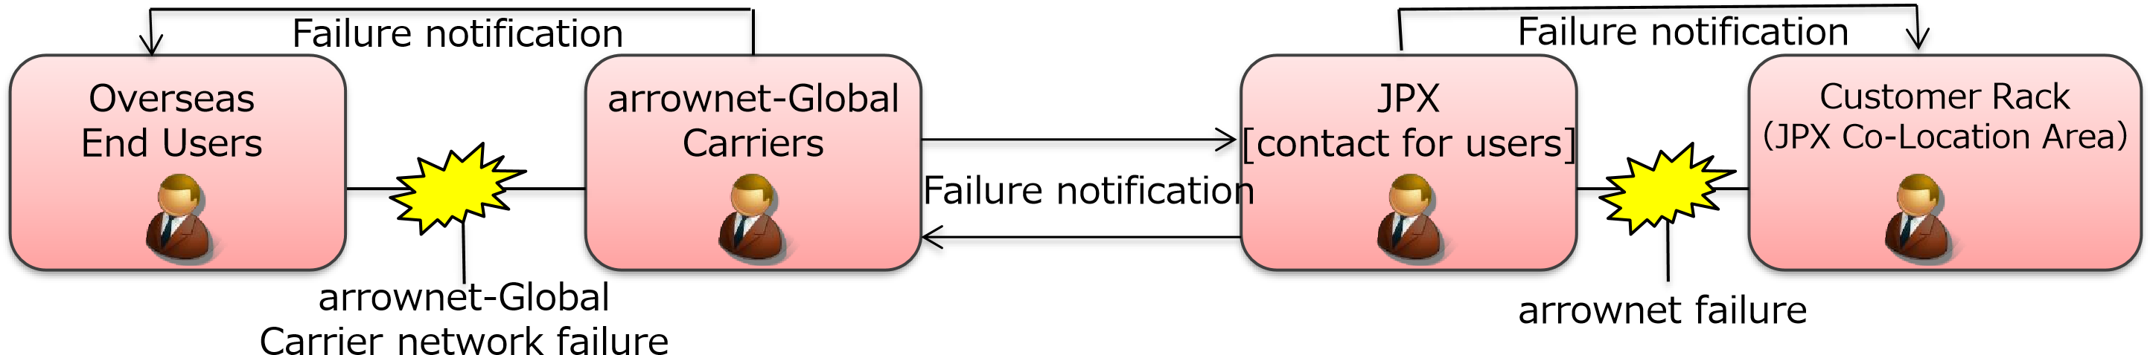
Fault report service desk contact
*1 Please contact JPX by telephone in addition to e-mail if you require service JPX Market Innovation & Research, Inc. Client Services Dept., during non-business hours (from 6:30 p.m. to 7 a.m. (JST) on weekdays,
Service Desk (arrownet support) weekends and holidays) or need immediate action within 24 hours.
Tel: +81(0)50-3819-1030 Please note that the service during non_{Japanese.} -business hours is available only in
E-mail: arrownet_support@jpx.co.jp
Available 24/7* (in English from 7am to 6:30 pm on business days)

2. Confirmation Items for Operations (2/3)

arrownet-Global accountability
- arrownet-Global Carriers should coordinate information sharing to End Users concerning connection specifications and service operations (includes troubleshooting).
- arrownet-Global Carriers bear responsibilities for their End Users to observe the restrictions of arrownet usage. If unforeseen circumstances are caused by End Users, the arrownet-Global Carrier assumes collective responsibility.
- arrownet-Global Carriers should serve as the contact for all inquiries concerning lines (application, payment and contact).

Service use restrictions
- It is prohibited to use the services for purposes other than connecting the End User’s external sites and JPX Co-Location rack.
  - Connecting different End Users in JPX Co-Location Area
  - Installing Internal Connection Lines in an Extranet rack and sending orders
- Time synchronization connection services provided by JPXI are as follows:
Service type | Availability to use services | Availability of distribution
GPS server connection service | Available | Unavailable
PTP server connection service | Unavailable | Unavailable

2. Confirmation Items for Operations (3/3)
Post-trade Direct

Pledge of operation
⚫ After official application of Post-trade Direct is submitted by arrownet-Global Carrier, the user must submit a pledge of operation to JSCC, which is the organization of destination system.
✓ The pledge is to confirm that the user maintains the necessary business operation structure in Japan even when using Post-trade Direct. For details, please contact JSCC directly from the user.

Application /connection specifications related to business systems
- When applying for a business system, the user sends required information to JPX ServiceDesk, and the application will be prepared on behalf of arrownet-Global Carrier who is the line contractor.
* Therefore, there is no procedure for arrownet-Global Carrier to apply for business systems.
After the application is approved, the user can refer to the information on arrowface.
- The user directly obtains the specification documents of the business system from the destination organization.

Connectivity Test
- In connectivity test, the reachability to the network, the normality of failure detection, etc., are confirmed, so that there should be no problems with the network when users start using Post-trade Direct.
✓ For details, please refer to “Guideline for arrownet Network Connectivity Test.pdf”.
- The user and the carrier set the schedule of connectivity test, and the carrier submits the application to book a test window via arrowface. By including the contact information of the user in the test booking application, a test result email can be received by the user.
- The connectivity test can be conducted only by the user.

Line failure notification
- When a network failure occurs, JPX is in communication with arrownet Global Carrier.
- arrownet-Global Carrier are responsible for contacting their End Users (Overseas users).
- Please note that arrownet-Global Carrier of Post-trade Direct can register several sets of contact information per each line. Therefore, by registering the user's contact information to the line, it is possible for user to directly receive the trouble notification from JPX and the maintenance notification mail. Changing contact info can be done on arrowface.
- JPX will contact the user directly for business system-related matters.

3. Demarcation Point and Responsibilities
- Demarcation Point and Responsibilities for arrownet-Global line connection are as follows:
- Physical provision scope and responsibility demarcation point in JPX is between the patch panel port installed within Customer’s rack located at either of the JPX Co-Location Area and the cable (stored on external connections side) which is connected to the terminal unit (ONU) at each Access point. (Please see below the dotted line area)
* Even in Post-trade Direct, the responsibility of the arrownet-Global Carrier is the same as that of other arrownet-Global.
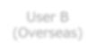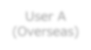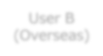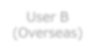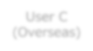
JPX Co
-
Location
User

Rack
User Rack
AP

arrownet
-
Global

Carrier NW
User B
)
(
Overseas
User A
(
Overseas
)
Carrier POP
)
JPN
(
Carrier POP
(
Overseas
)
User B
Overseas
)
(
User B
Overseas
(
)
ONU
PP
PP
arrownet
Global Carriers’ area of responsibility
JPX’s area of responsibility
End User’s area of responsibility
Partner Rack
User C
)
Overseas
(
Clearing system
*For more technical information not mentioned in this document, please refer to chapter 9 in "arrownet Guidelines for NW Connection (Common)“, chapter 7 in "arrownet Guidelines for NW Connection (JPX)“ and “arrownet Guideline for AP3 Co-Location External Exclusive Connection”.

5. Contact List

5. Contact List

Designated carriers Contract list
Company name | Department | Contact
NTT docomo  Business | Business Solution Division First Business Solutions | e-mail：Exchange-Connectivity@ntt.com
KDDI | Solution Sales Division  Financial Sales Department Sales  Group #4 | Tel：+81-3-6678-1568 e-mail：arrownet@kddi.com
Colt technology | Sales switchboard | Tel：+81-3-4560-7100  Email： sales-japan@colt.net
Softbank | Sales Department 1 Sales Division 2 1st Sales Division | Tel：+81-3-6889-9320  Email：SBTMGRP-arrownet@g.softbank.co.jp
@Tokyo | Corporate Sales Group #3-1 Sales Div. | Tel：+81-3-6372-3593 e-mail：ap3_sales@attokyo.co.jp

JPX contact
JPX Market Innovation & Research, Inc.
Client Services
Tel: +81-50-3822-8888 e-mail: j-colo@jpx.co.jp

Revision History
Version | Date of Revision | Section | Revision Content
1.0 | Oct. 15, 2020 | ‐ | Issued version 1.0
1.1 | Dec. 1, 2020 | 4-2. Confirmation Items for Operations  (1/2)  5. Contact List | - Revising Fault report service desk contact  - Updating Designated carriers Contract list
1.2 | Mar. 1, 2021 | 1-4. Extranet Service | • Added notes about Inter-user connection
 |  | 2-2. Price List for Dedicated Line  2-5. Price List for JPX-Chicago Co-Location  Direct  2-8. Price List for Extranet（1/2） | - Added AP3 Co-Location External Exclusive Connection  - Clarified conventional Co-Location external dedicated line is connected to AP1/AP2.
1.3 | June 17, 2021 | About This Guide  4-1. Technical Restrictions (2/4)  4-1. Technical Restrictions (3/4)  4-3. Demarcation Point and  Responsibilities | - Added “arrownet version2.0 Guideline for AP3 Co-Location External Exclusive Connection” on Document list  - Added “arrownet version2.0 Guideline for AP3 Co-Location External Exclusive Connection” as related document  - Added the technical restrictions of “arrownet version2.0 Guideline for AP3 Co-Location External Exclusive Connection”  - Added the related document to refer the demarcation point of “arrownet version2.0 Guideline for AP3 Co-Location External Exclusive Connection”
1.4 | Jan. 7, 2022 | 5. Contact list | • Updated contact information
1.5 | Apr. 1, 2022 | All | • Revised the contents in accordance with establishment of JPXI
1.6 June 1, 2022 All • Added Post-trade Direct
1.7 | July 1, 2022 |  | All | •  • | Deleted the contents regarding AP1  Deleted the contents regarding Co-Location  Service Dedicated Line (AP1/AP2)

Revision History
Version | Date of Revision | Section |  | Revision Content
1.8 | August 1, 2025 | All  4-1. Technical Restrictions (2/6) 4-1. Technical Restrictions (5/6) | •  •  •  • | Revised the company name of NTT docomo  Business  Revised the name of the service from arrownet v2 to arrownet  Revised the physical interface on Co-Location side Deleted the description about constraint of usage of IP addresses

